REF: SACT09/2018
Self-Assessment Basic Compliance Checklist for Employment Agencies with Comprehensive Licences who can only place Singaporeans/PRs

The basic compliance checklist assists you to recognize gaps in your employment agency’s compliance to the Employment Agencies Act and its subsidiary legislation, which can be found at http://www.mom.gov.sg/legislation/employment-agencies. It is however not exhaustive, but provides a starting point for employment agencies to perform self-assessment.

No | Compliance Items | Yes | No
Ensuring Professionalism of EA Industry
1 | EA Name and Licence Number (wef 1 Jun 16)  The EA name and licence number are inserted on:  - any signboard bearing the name of the EA and is visible to public  - any document issued or sent to any other party in the course of the EA’s performance of any function as an EA (including but not limited to invoices, receipts, service agreements, employment contracts and correspondence (whether electronic or otherwise)  - any advertisement publicizing any work or activity for or in connection with the employment of persons (such as but not limited to the EA’s website, name cards, pamphlets and publicity material on any social media platform)  - any advertisement (whether electronic or otherwise) distributed to the public by any other person on the licensee’s behalf
2 | EA Personnel Name and Registration Number (wef 1 Jun 16)  The full names and registration numbers of EA personnel, as stipulated in the EA personnel’s registration cards are inserted in any document or advertisement referred to under item 1 of this checklist.
3 | Personnel Registration  The EA registers all personnel who are performing EA work with MOM.
4 | The EA has at least one Key Appointment Holder who is registered with the Ministry (wef 1 Sep 18)
5 | Registration Cards  The EA’s registered key appointment holders and other EA personnel have Registration Cards which are in line with MOM’s requirements. (Refer to EA Rules 2011 for specifications, or refer to the last page for graphical representation).
6 | Deregistration of EA Personnel  The EA deregisters personnel who have left the EA’s employment or who have stopped performing EA work within 3 working days.
7 | TEP/TWP Holders  The EA does not place Training Work Permit or Training Employment Pass holders.
8 | Update Information to MOM  The EA updates MOM within 7 working days, if there is a change in EA’s place of business.
9 | Any change in any business registration details with ACRA is updated in Licence One.
EA’s Duty of Care to Applicants for Employment
10 | Condition for Placement  The EA is only involved in the placement of locals and Singapore Permanent Residents.
11 | Fees  The EA does not charge an applicant for employment more than 1 month’s salary for each year of validity of the applicant’s work pass or period of contract, up to a maximum of 2 months’ salary.
12 | Prescribed Fees  The EA shall not charge or receive any form of fees, remuneration, profit or compensation otherwise than the prescribed fees.
13 | Refund  The EA refunds at least 50% of fees received from an applicant if the employer fails to employ the applicant or if the employer terminates the employment within 6 months.
14 | Itemized Receipt  An itemized receipt for fees received, whether directly or indirectly, is issued to applicant. The receipt should inform the applicant how much the Singapore EA is charging him/her.
EA’s Duty of Care to Employers
15 | Dispute Resolution Mechanism  The EA discloses to clients and applicants for employment the EA’s dispute resolution mechanism prior to engagement of service.
16 | Scale of Fees  The EA clearly communicates in writing the scale of fees to be charged to a client or an applicant for employment. The list of fees should be comprehensive and include all the chargeable services provided by the EA.
17 | If the EA wishes to inform prospective employers of fees, EA must not misrepresent the costs of MOM’s legal or administrative requirements (e.g. Costs of work pass application, etc), and must provide a breakdown of such costs to the prospective employer in writing.  (wef 1 Jul 14)
18 | After an employer engages the services of an EA, the EA must sign a written agreement with the employer which clearly states the breakdown of fees payable by the employer for MOM’s legal or administrative requirements. (wef 1 Jul 14)

For more information, you can visit our MOM website at the following link: http://www.mom.gov.sg/employment-agencies
⁺Please refer to the diagram below depicting regulations governing the EA Registration Card:
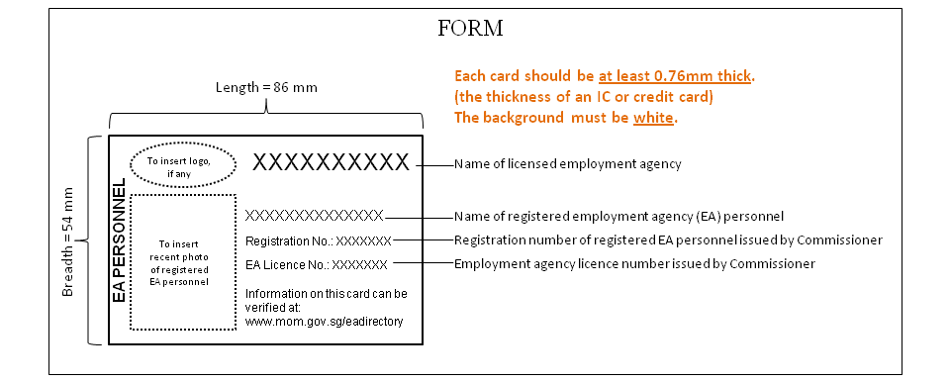
+ Kindly refer to the schedule of Employment Agencies Rules 2011 for full specifications.

